Ontario Provincial Committee of the Air Cadet League of Canada
DRAFT COPY revised 6 Feb 2015
Setting up and managing a Local Air Cadet Power Flying Program
The following information has been assembled to assist air cadet squadrons who may wish to organize and operate a cadet power familiarization program for their cadets. Squadrons should know that all local power flying activities must first be authorized and approved by their local detachment and Air Operations at Trenton.
It is the responsibility of the individual squadron to provide financial support for the activity and arrange for pilots and aircraft.
DATA COLLECTION
In order to a receive pilot and activity approval a cadet unit must submit the following data to their local detachment.
- The squadron must complete a copy of a Power Famil Flying Request that lists the following details, the location, possible flying dates as well as the pilot’s names and the registration numbers of the aircraft being used. They must also Complete Annex A - Pilot information form as well as an Annex B - Aircraft Information
Pilots flying aircraft owned and operated by a FTU must also provide copies of the following:
- A copy of the ID page, of their pilot licence as well as the licence page and their medical page.
- A copy of the last page of their log book showing their total hours as well as their PIC time. The record should also show that they are current on the type of AC that they will be flying.
- A copy of the notation in their log book showing that they have completed a proficiency check.
- A copy of an activity that indicates that the pilot has fulfilled his recency requirements.
A pilot who is flying a privately owned AC requires all of the above information as well as the following additional information.
- A copy of the insurance certificate for the aircraft. The certificate must show that the ACL and DND are named on the certificate. The insurance limits are listed on Annex B of the Power Famil Flying Request.
- A copy of the airworthiness certificate and a copy of the registration showing the owners name.
- If the aircraft is not owned by the pilot then there must be a copy of owner’s authorization to use the AC.

SUBMISSION OF A REQUEST FOR PILOT APPROVAL
Once the information and data has been assembled it is to be forwarded as an email to a units local Detachment ACO/ACA by the squadron CO who in turn will forward the request to Air Operations in Trenton for approval. All of the additional information required to support the request should be forwarded as email attachments. Care should be taken control the size of attachments as an email cannot exceed 10 MB.
RECEIPT OF PILOT APPROVAL
Once the request has been reviewed and approved the Detachment will forward a unit an Air Operations Tasking Order as well as an activity approval form to authorize the activity.
FREQUENTLY ASKED QUESTIONS
AUTHORITY TO CONDUCT LOCAL CADET POWER FLYING OPERATIONS
Local Cadet flying operations are officially authorized by CRCO 1821, CATO 52-07 and A-CR-CCP-242 Chapter1, Section 4.
BASIC REQUIREMENTS
What are the basic pilot standards required to fly air cadets?
Pilots wishing to fly cadets must meet the following minimum flying hours.
Minimum total flying time 150 hrs., minimum pilot in command time 75 hrs., minimum time on type 15 hrs., minimum time on type in last 60 days 1 hr.
Can a squadron utilize pilots that have been approved to fly cadets from another squadron?
Once a pilot is approved to fly cadets by air operations he or she may fly cadets from other cadet units providing that an approved ASR has been issued by the local detachment. In such cases squadrons must consult and work with each other to ensure that both units have successful flying operations.
A TASKING ORDER
What is an Air Operations Tasking Order?
A tasking order is confirmation from Air Operations in Trenton that a squadron has the authority to conduct cadet familiarization flying. It specifies the names of the authorized pilots as well as the two month time period during which the flying may be carried out. The order also details the restrictions and limits that apply when carrying out cadet flying operations. A sample is attached to this email.
PILOT PROFICIENCY CHECKS
What is a Proficiency Check?
A proficiency check is not a flight test but rather a check flight with a flight instructor to ensure that the individual who wishes to fly cadets is familiar with the safety features of the aircraft and that he or she is familiar with safety actions that would be required in the case of emergencies.
Who are required to have proficiency checks?
All pilots including flight instructors wishing to fly cadets are required to complete a proficiency check once a year. In the case of a flight instructor requiring a check another flight instructor is required to carry out the procedure. Once a proficiency check is completed the flight instructor is to annotate the individuals log book with a statement that such a check was carried out. He should date the entry sign his name and include his licence number. See annex C for a sample of the statement that should appear in a pilot’s log book.
When should proficiency checks be carried out?
Proficiency checks are sometimes difficult to arrange due to weather, availability of aircraft or staff and this can seriously delay the start-up of a units flying program. It is suggested that units wishing to carry out proficiency checks should have them completed during the summer months. In that way a squadron could be ready to start flying in at the beginning of the cadet training year.
Proficiency Check – Log Book entry
The following is the information that is to appear in a pilots log book once a proficiency check has been successful completed. It is to appear opposite the log book entry showing the date, flight time and aircraft type. It is to of check and be signed by a flight instructor. The following information should also be shown
PILOT CURRENCY
What is meant by the term “pilot currency”?
All pilots who are approved to fly cadets must to remain legal, fly at least 1 hour in the preceding two month period.
How does a squadron renew the currency of an approved pilot?
An initial tasking order authorizes a pilot to fly cadets for the following two months. To obtain approval for the next two month period the squadron must send in to Air Operations at Trenton a copy of the pilots log book or a certification from a CFI that shows that the pilot has flown 1 hour in the previous two month period in order to maintain his or her currency. This will initiate a new tasking order to cover the next two month period. The initial submission of licences, proficiency checks etc. is required only once during a training year. Basic pilot approval as shown in the initial tasking order is in effect for a period of one year from the initial date of first the tasking order.
60 day currency/approval
For established and active squadrons and pilots Air Operations will consider approval periods longer than 60 days on a case by case basis. As long as Air Operations are receiving on time stats reports that show that the pilot is maintaining their currency by flying cadets, there isn’t a need for a 60 day resubmission/approval.
PILOT RECENCY
What is meant by a pilot’s recency?
Every two years a Pilot must complete a recurrent training activity. In order to satisfy this requirement a pilot can choose from the list of training programs listed on Annex A - Pilot Information. The details of the training activity should be listed on the email requesting the pilot’s approval.
SUBMISSION OF ADB, LICENCE, MEDICAL, ANNUAL PROFICIENCY CHECK AND RECENCY
How often are the above forms to be submitted to Air Operations?
These references only need to be submitted once. They are held on file and do not need to be resubmitted every time. They will need to be re-submitted when they expire (ADB – 5 yrs, Medical – varies, Prof Check – Annual, Recency – 2 yrs). The applicable (expiry) dates need to be included on the pilot info form every time. The same holds true for private aircraft documents. They only have to be resubmitted when they expire or change.

REPORTING OF CADET FLIGHTS
Does a cadet unit have to report the number of cadets flown?
It is the responsibility of the commanding officer of a cadet unit to report within seven days the number of cadets flown as well as the date of the flight, the pilots name and the hours flown to Air Operations at Trenton.
AIRCRAFT TYPE
If a pilot has completed a proficiency check on a Cessna 172 does that mean he or she is also approved to fly cadets in another four seat AC such as a Piper Cheroke?
Pilots are limited to flying cadets in the same type and model of AC in which they carried out their proficiency check. (APC)
NIGHT FLYING
Can cadets fly at night?
Cadet night flying is authorized and it can be used to add an interesting option to cadet flying activities. However, the pilot must possess at least a commercial pilot licence and possess a current and valid night endorsement.
To conform with air regulations a pilot must have made 5 take offs and landing with in a six month period to remain current in the class and category of aircraft in which the passenger is being carried.
CADET SUPERVISION
Is a pilot flying cadets required to have a police check?
Pilots authorized to fly cadets are not required to provide a police check.
Who is required to supervise a cadet flying operation?
A cadet officer or a civilian instructor must be in attendance on the ground to supervise cadets during cadet familiarization flying.
Should cadets wear uniforms when involved in flying operations?
It is suggested that cadets do not wear uniforms when participating in cadet flying operations as heavy boots and uniforms make it difficult to access and exit light aircraft.
FINANCING A CADET FLYING PROGRAM
How much does it cost to fly a cadet?
It is the responsibility of the local sponsoring committee to cover the cost of a Squadrons power flying activities. However some squadrons may ask cadets to contribute $10 to assist the sponsor in financing a cadet flying program.
If cadets contribute $10 towards the cost of a flight in four seat aircraft rented from an FTU and the flight is approximately .7 hour the cost to the sponsor will be approximately $30 per cadet. If the same flight is in a private aircraft then the cost could be $10 per cadet.
Can a squadron legally assist the pilot and owner of a private aircraft by paying for some of the costs incurred in the operation of their aircraft?
Reference CARs 401.28 A squadron can in accordance with air regulations financially assist the owner of a private aircraft with some of the costs involved in flying cadets providing that the amount does not exceed the basic costs required to operate and maintain the aircraft.
RESTRICTIONS
Can air cadet familiarization flights be carried out from a private or unlicensed airfield?
As long as the airfield is “suitable”, it can be approved. It can be private, public, licenced (airport) or unlicensed (aerodrome). The designated aerodrome will normally be listed in the Canada Flight Supplement (CFS). For aerodromes not listed in the CFS, sufficient information must be available for the RCA Ops O to determine that it is suitable for safe operation of the aeroplane.
EMAIL ATTACHMENTS
What is the best technique to transmit documents to Trenton?
Documents required for pilot approval should not be faxed as they do not always come through in a readable condition. The best method is to mail copies direct to Trenton or scan or photograph the data and then forward the copy as an attachment to an email.
Squadrons should remember that the size of an email with attachments is limited to 10MB.
THE APPLICATION FORMS REQUIRED FOR AIR OPPERATIONS APPROVAL ARE ATTACHED TO THIS EMAIL
Power Famil Flying Request
Annex A - Pilot Information
Annex B - Aircraft Information
The three forms above required by Air Operations are actually PDF files and information can be typed directly on to the form and then forwarded as an attachment to an email.
LOG BOOK ENTRY FOR A PILOT PROFICIENCY CHECK
Sample format of a log book entry for a proficiency check.
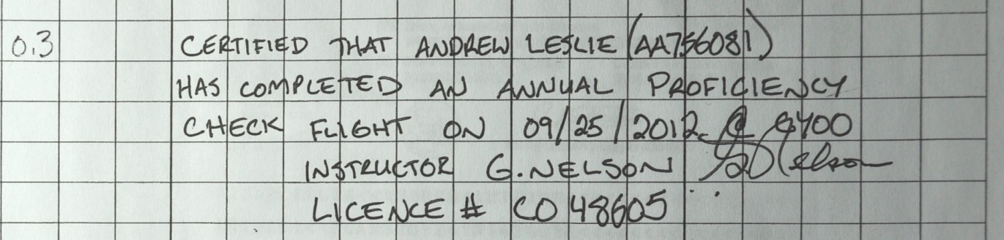
Prepared by: Ted Gilbank LCOL (Ret’d)
rgilbank@rogers.com 905 579 3103

Here are some cadet photos that could be used to illustrate a cadet power flying program

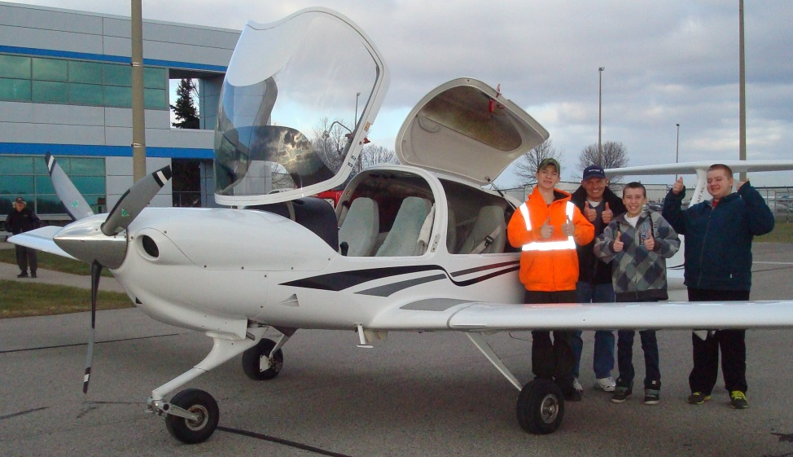
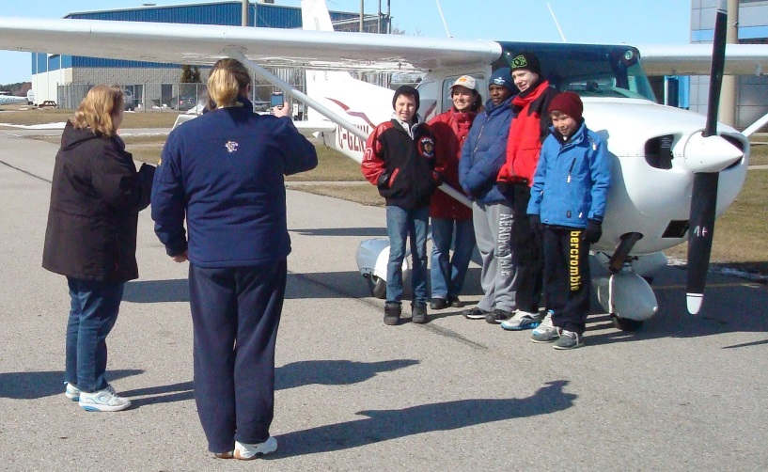

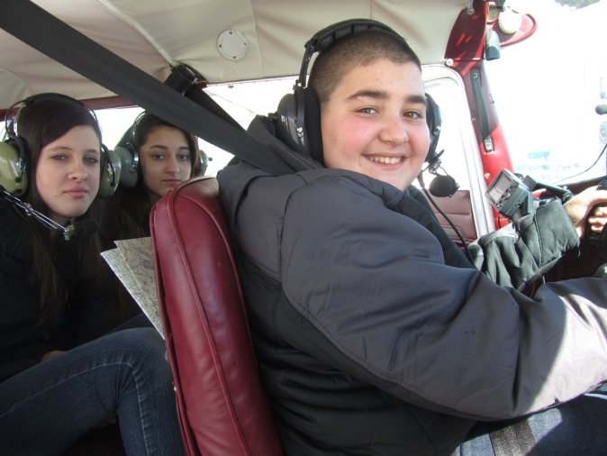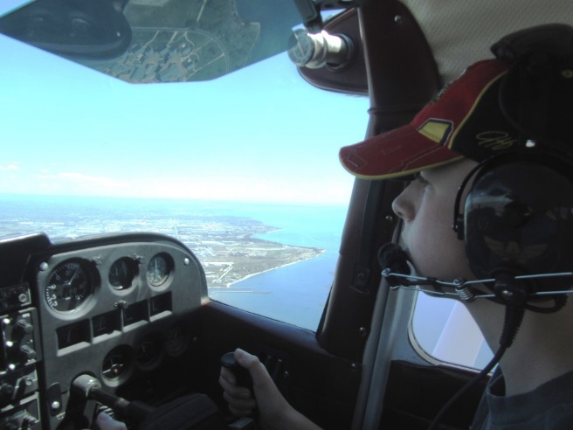

Night Flying
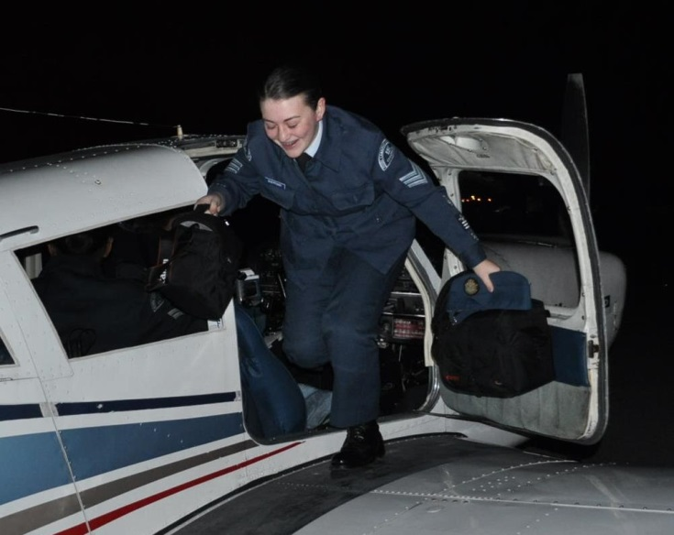

Activities Involving cadets in local airport operations
Oshawa Lions Club Easter Egg Hunt
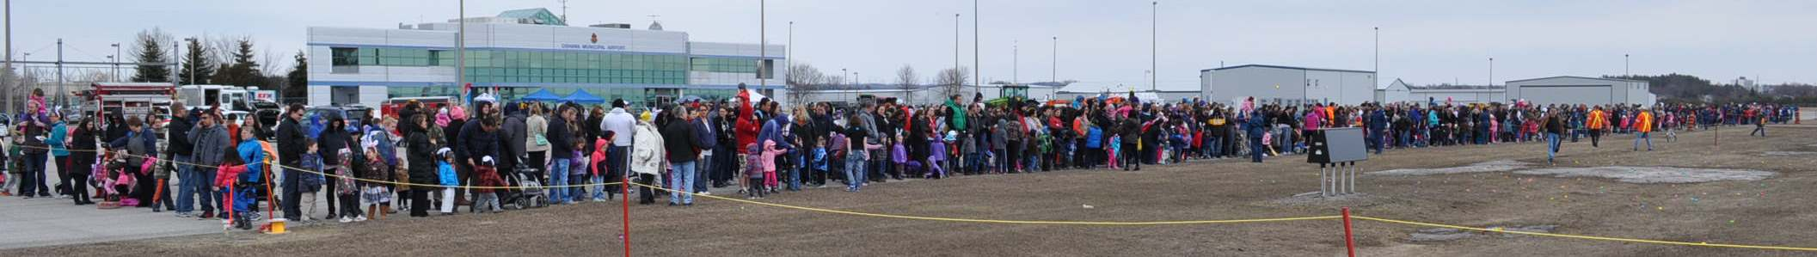

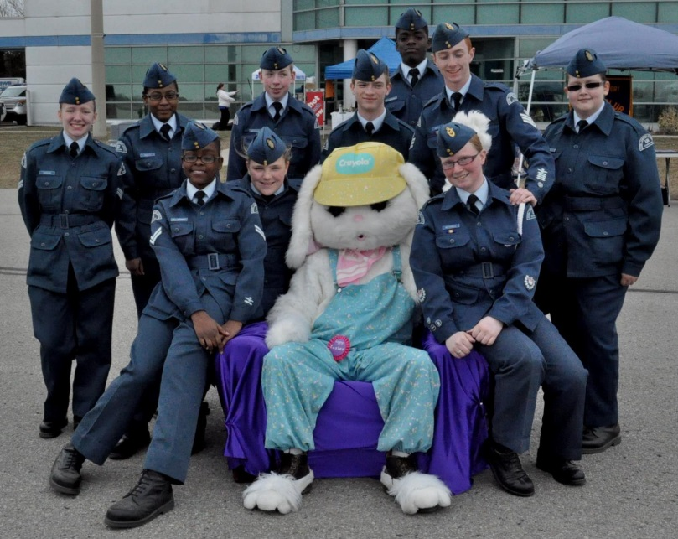

Battle of Britain Parade. A route march across a fully operational airport
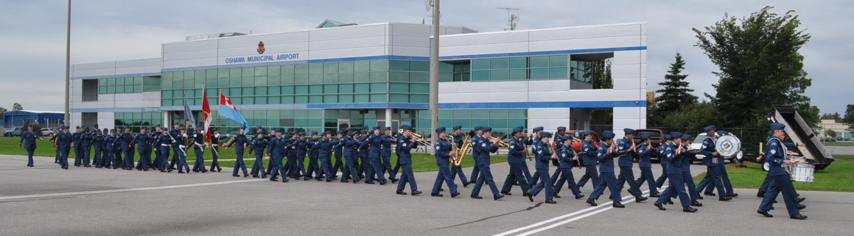
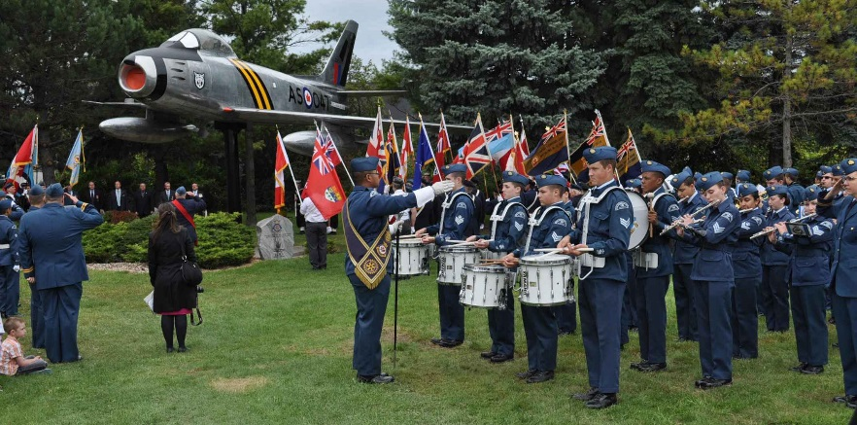

Hawke Field Flyin
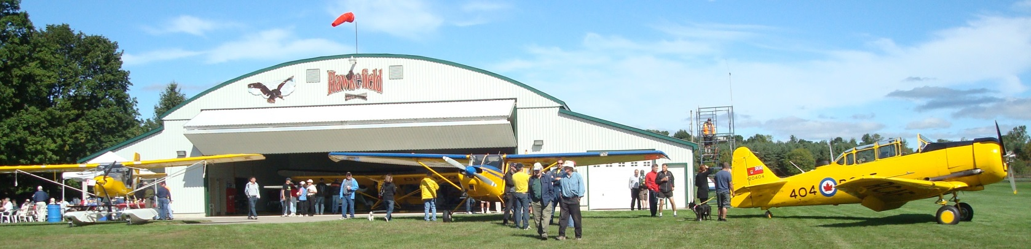
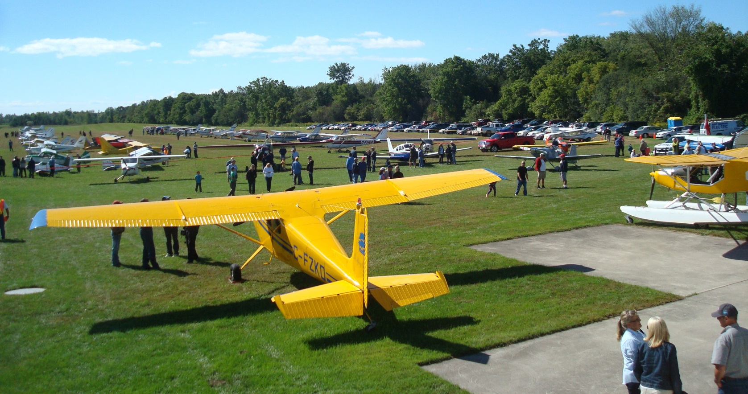
Bill Lishman (Movie Fly Away Home)
